Name
University affiliation
Date
WhatsApp mobile app and web app
A mobile app is made for a particular device and has to first of all be installed onto that particular device. The users of mobile apps often download the apps from the online stores such as the Apple App Store as well as Google Play Store depending on the operating system of your device. A web app on the other hand is internet based app which is accessible through a web browser. It does not have to be downloaded or stalled to access. I will make a comparison between the WhatsApp mobile app and its web app. It will be important to differentiate between a mobile app and a web app.
A WhatsApp web app can easily be accessible to its users simply via a browser and can be accessible by many devices at ago. It is more compatible because it enhances the user experience when using different types of devices. When you own several, you can appreciate the compatibility and the responsiveness of the web app. The web app also has a broader reach when compared to the mobile app. This is possible because any user can use different devices to access the same version of the web app hence that makes it win in-terms of usage by many clients. WhatsApp web app can also be easily shared amongst one another through a link. This can be within either a text email, post on Twitter or Facebook on the other hand, A WhatsApp mobile App cannot be shared easily like how a web app can be shared,
WhatsApp web app is easier and even less expensive than the WhatsApp mobile app. This is because if you need a presence of a WhatsApp mobile app on various platforms, the company will need to develop multiple apps. A WhatsApp mobile app will require regular support and maintenance due to issues such as testing, upgrades and compatibility issues. However, WhatsApp web app has its disadvantages too, for instance, its user experience is unsatisfactory since it only allows a single window restriction. It can just work when one is online and not when you are offline. The developers of the WhatsApp web should collaborate and come up with web apps that have a better user experience. They should also work to ensure that the web app does not have a limited scope when accessing features on a mobile device.
WhatApp web app

WhatsApp web app cost less and it is more dynamic in terms of upgrading when compared to the mobile app. This is because all you need is to maintain a single version even when it gets updated. If the developers want to change any content on the web app, they will only have it published and edited, through that, the chances are visible. Mobile apps, on the other hand, require one to download another version when the app is updated. The WhatsApp mobile app allows its users to set preferences, creation of personal accounts as well as the keeping of important information at hand.
WhatsApp mobile app is more convenient and more straightforward to use. I guess this is the reason it has many users when compared to the web app. It provides a better user experience, and its speed is 1.5 times faster when loading of contents and even more comfortable when using. It is made in a way that it allows one to use device-specific hand gestures. WhatsApp mobile app is gradually developing a different convention purposely for interaction, making it likeable by many because it responds as per the expectations of the user. Another important and unique feature of the WhatsApp mobile app is that it has push notifications, which can be used when you need any updates and reminders directly on your mobile device. With it, you can get updates and reminders on your mobile device.
WhatsApp mobile app
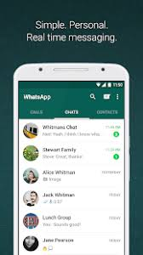
WhatsApp mobile app performs faster because it stores typically its information locally and has to synchronise with the server the moment the user has finished using the app. Another advantage of using the mobile app is that it can be used even when one is offline. Since the apps are directly installed on one's device, you can comfortably access its contents and features without the internet connection. The mobile app also allows its users to define and set their preferences from the very beginning. The mobile app can observe the engagement behavior of its users and then offer recommendations and carefully filter updates for users on the basis of their location in real time. The device features on the app do shorten the time one might use to initiate and also perform various actions which makes the user change the manner in which one interacts with his/her device and the app itself.
Whats App web app is more compatible because it enhances the user experience when using different types of devices. When you own devices of different types, you can appreciate the compatibility and the responsiveness of the web app. The web app also has a broader reach when compared to the mobile app. This is possible because any user can use different devices to access the same version of the web app hence that makes it win in-terms of usage by many clients.
WhatsApp mobile app has its own disadvantages. First of all, it can lead to faster drainage of the phone battery of the user. It also occupies your phone’s space, this is to mean that you cannot use the WhatsApp mobile app if you have limited space or no space at all on your device. The mobile app may also not be compatible with other devices that use different operating devices. Therefore if you have different devices, that use different operating devices like Windows, Android or iOS, you will have to download separate versions of the WhatsApp mobile app that suits the operating system. The developers have to look into this and come up with an all-inclusive app to suit the needs of users. Despite some few disadvantages of the WhatsApp mobile app, they are so popular and I would choose the mobile app as opposed to its web version because of its faster performance and better user experience.

Images comparing WhatsApp mobile app and web app

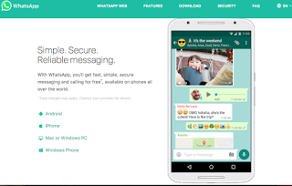
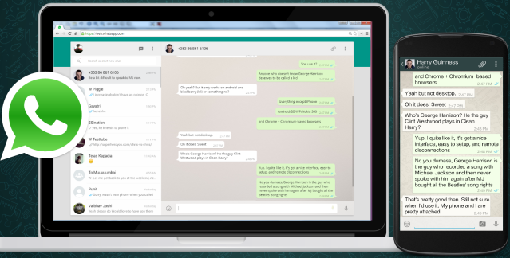

References
Fridman, L., Weber, S., Greenstadt, R., & Kam, M. (2017). Active authentication on mobile devices via stylometry, application usage, web browsing, and GPS location. IEEE Systems Journal, 11(2), 513-521.
Fu, B., Lin, J., Li, L., Faloutsos, C., Hong, J., & Sadeh, N. (2013, August). Why people hate your app: Making sense of user feedback in a mobile app store. (pp. 1276-1284).

